23 December 2012

2012 – RECORD YEAR FOR INCOMING TOURISM
WITH 3.5 MILLION ENTRIES
RISE IN REVENUES FROM TOURISM: NIS 36 MILLION
VOLUME OF TOURISM FROM RUSSIA INCREASES BY 20% AND IS NOW EQUAL TO THAT OF USA

TOURISM MINISTER STAS MISEZHNIKOV: “THESE ACHIEVEMENTS ARE A REFLECTION OF THE INTENSIVE AND PROFESSIONAL WORK OF THE PAST THREE YEARS, WHEN TOURISM HAS BECOME A MAIN ENGINE FOR GROWTH IN THE ECONOMY WITH A RISE IN REVENUES AND THE CREATION OF NEW JOBS. MAKING TOURISM A PREFERRED NATIONAL INDUSTRY WILL STRENGTHEN ISRAEL IN ECONOMIC, IMAGE AND ADVOCACY TERMS”

3.5 million visitors to Israel will have arrived in Israel by end 2012, 4% more than in 2011. Tourists (not including day visitors) account for 2.9 million entries, 2% more than in 2011. Despite the downturn that occurred in the last month and a half as a result of Operation Pillar of Defense, this year sets a new record for incoming tourism to Israel.

As in previous years, the USA remains the largest single source country for incoming tourism with about 610,000 visitors, representing 18% of all tourism to the country and a drop of 4% on last year. In second place and with a very small margin is tourism from Russia with 590,000 visitors, 20% more than 2011.

Out of 3.5 million visitors, 2.5 million arrived by air (70%), an increase of 1% compared to 2011. About 406,000 came through the land borders (12%), an increase of 6% compared to 2011. 625,000 entries (18%) were one-day visitors, an increase of 15%: of these 235,000 came on cruise ships, a similar number to 2011.

About 16.5 million domestic overnight stays were registered in 2012 in all the various types of accommodation, 3% more than last year. There was an increase of 4% in hotel stays, 2% in youth hostels and ½% in rural tourism.

Revenue from incoming tourism in 2012 (including the income of the Israeli aviation companies from inbound tourism) totals about $4.6 billion or 17.8 billion NIS (an increase of 8% - largely due to the increase in the dollar rate). Revenue from domestic tourism in 2012 totals about 10.3 billion NIS (3% more than in 2011), and another 8 billion NIS in revenue from outbound tourism – similar to 2011. Total revenue from tourism in 2012 is estimated at about 36 billion NIS, 4% more than in 2011.

Further details in the overview below:

INCOMING TOURISM IN ISRAEL 2012
AN OVERVIEW

3.5 million visitors to Israel will have arrived in Israel in 2012, 4% more than 2011. The number of tourist entries (not including day visitors) will total 2.9 million entries, a 2% increase compared to 2011. The year 2012 sets a new record for incoming tourism, despite the downturn in the last 6 weeks of the year.

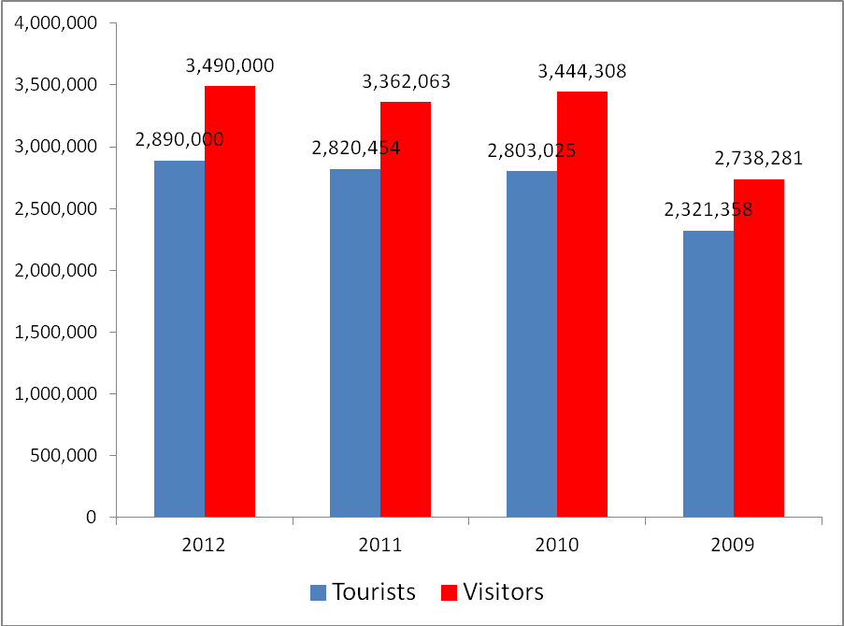

The year 2012 was characterized by a continuing upward trend from February through to October 2012, but this changed in the middle of November with the onset of Operation Pillar of Defense. Despite this, 2012 sets a new record for incoming tourism to Israel.

- Tourism by mode of travel

Out of 3.5 million visitors, 2.5 million arrived by air (70%), an increase of 1% compared to 2011. About 406,000 came through the land borders (12%), an increase of 6% compared to 2011. 625,000 entries (18%) were one-day visitors, an increase of 15%: of these 235,000 came on cruise ships, a similar number to 2011.

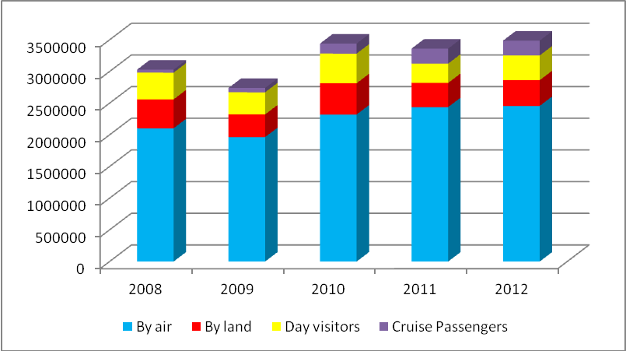

- Tourism by Country of Origin (visitors, including day visitors – not including cruise ships)

As in previous years, tourism from the USA continued to represent the largest country of origin for incoming tourism to Israel, with 610,000 visitors arriving in 2012, (representing 18% of all incoming tourism), a decrease of 4% compared to 2011. In second place and with a very small margin is tourism from Russia with 590,000 visitors, 20% more than 2011. Tourism from France takes third place, with about 300,000 visitors (similar to last year), followed by Germany (230,000; 4% more than 2011) and the United Kingdom with 208,000 visitors each, 6% less than 2011. Other countries worthy of note: Italy with 170,000 visitors, 12% more than last year; Ukraine with 140,000 visitors, a 2% increase compared to 2011; Poland, 103,000 visitors, 7% more than last year; , 72,000 visitors from Canada (6% down on last year) and 58,000 from Spain (3% increase on 2011).
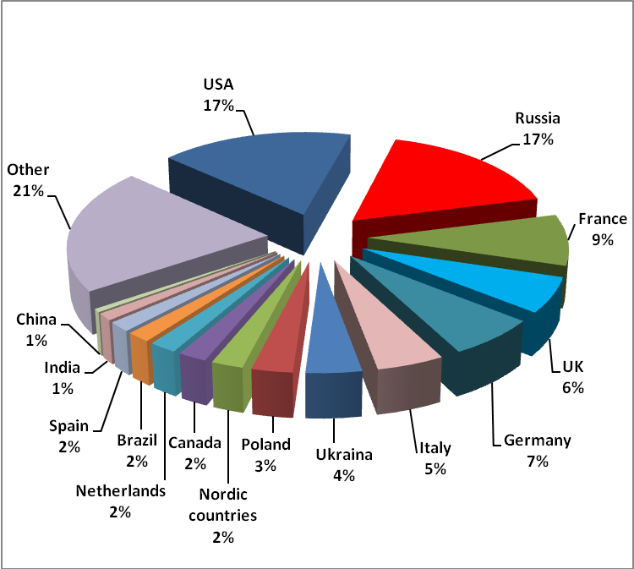

- Leading Countries of Origin (tourists, excluding day and cruise visitors):
In first place, USA with 580,000 tourists, similar to last year. In second place and with a wide margin, Russia with 380,000, 8% more than last year. In third place, France with 261,000, (3% less than 2011). In fourth place, UK with 165,000 followed by Germany with 159,000, Italy with 128,000, Ukraine with 110,000, Canada with 65,000, Poland with 60,000, and Spain with 51,000 tourists.

- Tourism to Israel: Characteristics
- 58% of incoming tourism was Christian tourism (about half of which is Catholic), 23% Jewish tourism, with the remaining of other religious denominations or non affiliated.
- 62% of tourists were first time visitors, and 38% returning visitors.
- 29% defined their visit as part of a pilgrimage, 24% as tour and travel, 9% as vacation and leisure. Overall, 62% defined their visit for tourism purposes, 20% visited friends or relatives and 12% came for business or to attend conventions.
- 75% of tourists stayed in hotels, 16% stayed with friends or relatives and 5% stayed at youth hostels or religious hostels. The remaining tourists stayed in rented or owned apartments.

- Sites/Cities Visited
Jerusalem is the city most visited by incoming tourists in Israel, (77% of all tourists). Tel Aviv-Jaffa holds second place with 56% of all tourists having visited and in third place, the Dead Sea area with 51%. Tiberias holds fourth place with 44% of all tourists followed by Nazareth with 35%.

The most visited sites include the Western Wall (65%), the Jewish Quarter in Jerusalem (64%), the Church of the Holy Sepulcher (58%) and the Via Dolorosa (58%) and the Mount of Olives (56%).

- Tourist Satisfaction
The satisfaction level of tourists visiting Israel in 2012 was very good to excellent (4.2 out of 5 – excellent). Services that also received a high rating included: archeological sites and tour guides (4.2); personal security (4.0), the beaches and sea (3.8) and airport facilities (3.8). Among those services which did not rate so highly: cleanliness in public spaces (3.4); tax-free shopping (3.4), taxis (3.2) and value for money (3.1). The ratings registered an improvement compared to the 2011 satisfaction survey.

NB Points 4-6 refer to data, Jan-June 2012, Incoming Tourism Survey

- Hotels
During 2012, 340 hotels operated in Israel with a total of about 47,900 rooms. 70 hotels with 9,300 rooms operated in Jerusalem, 50 hotels with 11,000 rooms in Eilat, 53 hotels with 6,800 rooms in the Tel Aviv area, 15 hotels in the Dead Sea area with over 4,000 rooms and 47 hotels with 6,300 rooms in the Tiberias and Sea of Galilee area.

22 million bed nights were registered in these hotels through 2012, a slight increase on 2011. About 44% of these were from incoming tourists (9.7 million bed nights, 3% less than 2011). Since 2008, there has been a trend in tourist bed nights away from tourist hotels into other accommodation (youth hostels, Christian hostels and privately-owned/rented apartments). About 12 million bed nights (64% of the total) was from Israelis, an increase of 4% on 2011.

- Domestic Tourism

About 16.5 million domestic overnight stays were registered in 2012 in all the various types of accommodation, 3% more than last year. There was an increase of 4% in hotel stays, 2% in youth hostels and ½% in rural tourism and there was a decrease in stays in field schools.

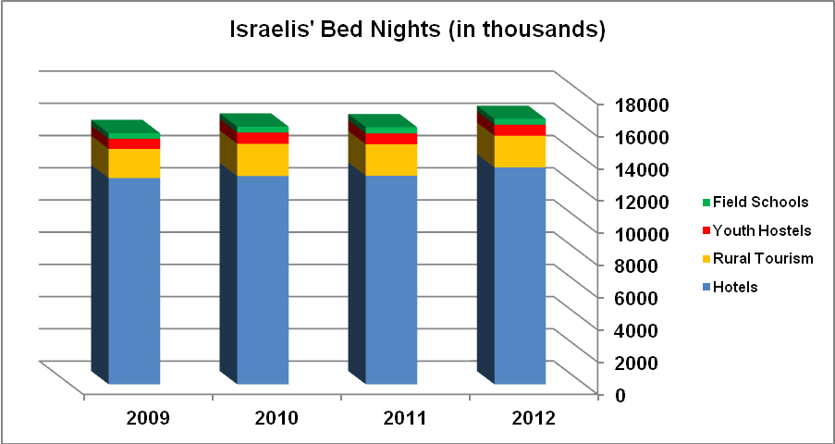

It should be noted that there was a slight decrease in the numbers of Israelis traveling overseas in 2012 as compared to 2011. Of those Israelis who traveled by air overseas, there was no change over last year, and a decrease of 10% in travel by land (to Egypt and Jordan). This decrease was in large part due to the 24% decrease in Israelis traveling to Egypt.

- Tourism's contribution to the Israeli economy
Revenue from incoming tourism in 2012 (including the income of the Israeli aviation companies from inbound tourism) totals about $4.6 billion or 17.8 billion NIS (an increase of 8% - largely due to the increase in the dollar rate). Revenue from domestic tourism in 2012 totals about 10.3 billion NIS (3% more than in 2011), and another 8 billion NIS in revenue from outbound tourism – similar to 2011. Total revenue from tourism in 2012 is estimated at about 36 billion NIS, 4% more than in 2011.
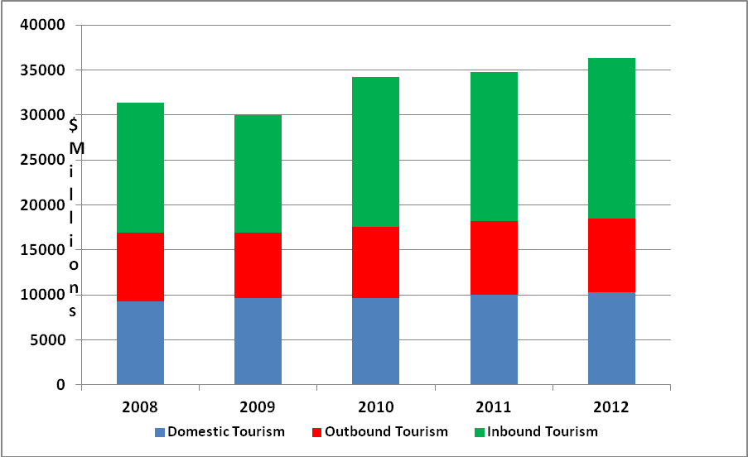

Employees in tourism
The number of employees in the Israeli economy as a result of tourism activities stands at 105,000 in 2012, approximately one third of whom are employed in hotels. The total number of employees related to the tourism industry (direct and indirect) stands at about 209,000, 7.8% of all employees in Israel.

Sources, tables and graphs: Ministry of Tourism Statistics Department

Provisional data, estimates by the Statistics department in the Tourism Ministry.

