**THE EMBASSY OF ISRAEL TO LATVIA AND LITHUANIA**

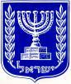

**Culture News from Israel**

**No. 5/2013**

**CONTENTS:**

VISUAL ARTS

* Deganit Berest: The Conspiracy of Nature
* Elad Kopler: Temperatures
* Fresh Paint

DIFFERENT FESTIVALS

* Masada Project
* Festival of Light in Jerusalem
* National Hebrew Book Week

IT IS INTERESTING

* Dead Sea Scrolls Online
* Formula 1 in Jerusalem

**VISUAL ARTS**

# Deganit Berest: The Conspiracy of Nature

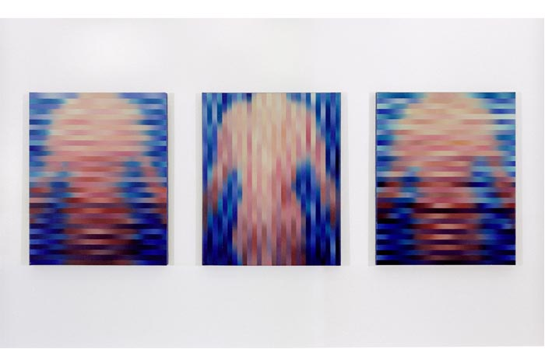

On May 18, Deganit Berest exhibition was opened at the Joseph and Rebecca Meyerhoff Pavilion, in the Main Building of the Musuem. An artist creates in her artistic oeuvre – series of photographs, of paintings and of combined photography and painting – a fascinating dynamic between the media, doubting their purity. Berest belongs to the first wave of conceptual artists who raised feminist consciousness in Israeli art. The artist is the winner of the 2012 Rappaport Prize* for an Established Israeli Painter.

More about the artist: <http://www.artiscontemporary.org/artist_detail.php?id=67>

Source and for more information: <http://www.tamuseum.com/en/default.aspx>

*Back to Contents*

# Elad Kopler: Temperatures

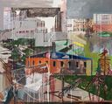 On May 18, Elad Kopler’s exhibition was opened at the Jeannette Assia Galleries, in the Main Building of the Musuem. The artist’s paintings deal with the disintegration of the real world, which also embodies the disintegration of the formalistic world of painting. It is a world laden with dissonance, expressed through paintings of ruins, crumbling buildings and deserted towns, depicted with strong brush strokes, expressive colors and painterly gestures veiled by a haze that blocks their vitality. Elad Kopler is the winner of the 2012 Rappaport Prize* for a Young Israeli Painter.

Source and for more information: <http://www.tamuseum.com/en/default.aspx>

*Back to Contents*

* *The prize is awarded annually, since its establishement in 2006, on Baruch Rappaport's birthday to two painters, – an established painter and a young one. It is set to be awarded for a total of 10 year and at the end of the period there are plans for an exhibition featuring works by all the prize recipients over the years.*

# Fresh Paint

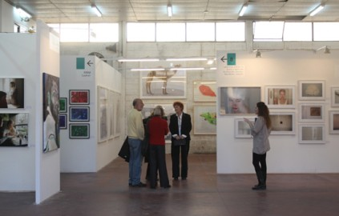

Six years ago Fresh Paint art fair was founded as a catalyst for the Israeli art field’s activity, proving a great success. Today the fair’s team extends its activity to include the area of design, so the established and familiar art fair, and the new and intriguing design fair –took place in May, 2013, on a single site, in separate venues, offering their visitors double the experience.

Source and for more information: <http://www.freshpaint.co.il/en/fresh-paint>

*Back to Contents*

**DIFFERENT FESTIVALS**

# Masada Project

**Masada Project, taking place form May 30 till June 1, at the Masada Hall,** is to bring together the very best of Israeli performers and start a tradition of a unique music festival at the world's lowest geographical point.

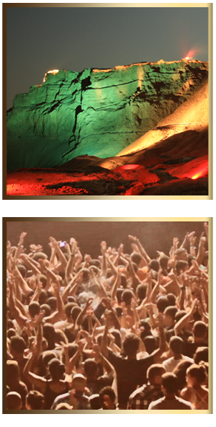

Source and for more information: <http://www.masada-hall.co.il/pages/english>

*Back to Contents*

# Festival of Light in Jerusalem

The third Festival of Light will take place from June 5 till June 13, 2013, in the Old City of Jerusalem.

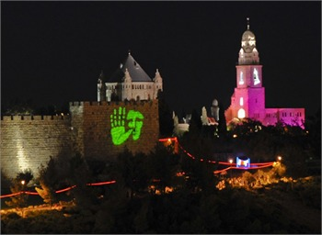

Source and for more information:

<http://www.jerusalem-oldcity.org.il/pages_e/Light_Festival.aspx>

*Back to Contents*

# National Hebrew Book Week

National Hebrew Book Week is an event with large outdoor book fairs, special Book Week sales at bookstores all around the country, and a variety of accompanying events such as music, performances, children's events, workshops, and storytelling.

[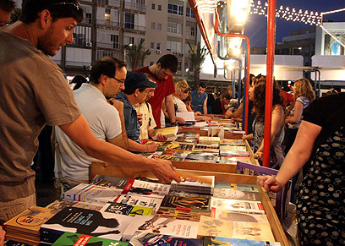](http://www.google.lv/url?sa=i&rct=j&q=&esrc=s&frm=1&source=images&cd=&cad=rja&docid=_qcOxXOTZRDn4M&tbnid=eyynfX2QbzTP9M:&ved=0CAUQjRw&url=http%3A%2F%2Fwww.ynetnews.com%2Farticles%2F0%2C7340%2CL-3731660%2C00.html&ei=LL-lUdv0I8Wc0AX8tICwAg&bvm=bv.47008514,d.ZG4&psig=AFQjCNE1JfKW2-Qyj0esPkUxBJRkP1Ae3Q&ust=1369903231899269)

More information just in Hebrew: <http://www.sfarim.org.il/shvua_hasefer/?page_id=58>

*Back to Contents*

**IT IS INTERESTING**

# Dead Sea Scrolls Online

The Dead Sea Scrolls including the oldest known biblical manuscripts in existence have been digitized and are accessible online:

<http://www.youtube.com/watch?feature=player_embedded&v=5rYj_0foJYA>

Source and for more information: <http://dss.collections.imj.org.il/>

*Back to Contents*

# Formula 1 in Jerusalem

For the first time in history, this June, Formula One cars will make their way through the streets of Jerusalem for a unique spectacle, "Formula 2013: The Peace Road Show."°

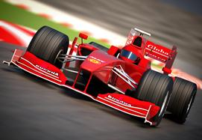

Source and for more information: <http://www.itraveljerusalem.com/formula-one>

*Back to Contents*