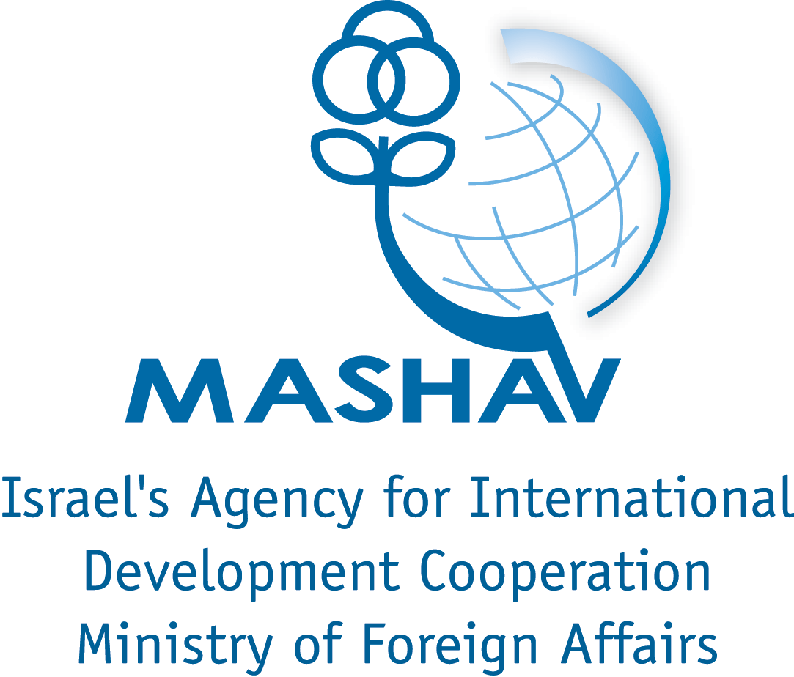


International Training on
“Clean Technologies – Environmental technology, innovation and management systems as means for regional and local economic development”
From 14 January to 07 February 2013
Organized by the Weitz Center for Development Studies

Clean Technology (Cleantech) is commonly defined as a diverse range of products, services, and processes that harness renewable materials and energy sources, dramatically reduce the use of natural resources, and cut or eliminate emissions and wastes. Cleantech is relatively a new phenomenon of economic development. As such, cleantech is increasingly recognized as a vital component for economic growth and has seen a significant rise in economic activities. For example, the markets for clean energy technologies grow from less than $7 billion in 2001 to over $188 billion in 2010. This staggering increase is a result of the growing constrains to economic growth due to environmental degradation, high oil prices, scarcity of natural resources and climate change. Therefore, some regard cleantech as the beginning of a revolution that is changing the places where we live and work, the products we manufacture and purchase, and the development plans of cities, regional governments, and nations around the globe.

Clean Technology includes a wide verity of environmental, social and economic activities predominantly comprising the fields of:
- Recycling – reuse of resources in an efficient way reducing the cost of production and environmental pollution.
- Renewable energy - introduce new forms of energy production wind power, solar power, biomass, hydropower and biofuels
- Information technology – The use of computerized systems and information processing to reduce the use and strain imposed on natural systems, such as computerized watering systems etc'.
- Green transportation – transport with low impact on the environment such as non-motorized transport, green vehicles, Car Sharing, and urban transport systems that are fuel-efficient, space-saving and promote healthy lifestyles.
- Green chemistry - design of products and processes that minimize the use and generation of hazardous substances. Green chemistry seeks to reduce and prevent pollution at its source.
- Energy efficiency technologies – reducing energy consumption e.g. Lighting- Compact Fluorescent Lights or LED lighting.
- Water technologies – water desalination, water purification, waste water treatment, etc’.
- Green buildings – Architecture, design, construction and maintenance of building that hold a small environmental footprint.

Cleantech and developing countries
Around 1.3 billion people across the world have no electricity at all; contaminated drinking water and an inadequate supply of water cause diseases that account for 10 percent of the total burden of disease in developing countries; and some 925 million people were undernourished in 2010. These are only some of the challenges developing countries need to tackle. Cleantech offers an environmentally sound answer to deal with some of those problems. Communities can be connected to electricity without the need to build a complex national grid, waste can be collected and turned into energy, and water can be purified to provide safe drinking water. Therefore, the realization of clean technology is twofold: technologies, and implementation - utilizing a better understanding of socio-economic factors in the move towards sustainable development. The above training will provide participants with knowledge of those two factors introducing new clean technologies and illustrate implementation mechanisms such as: societies and support systems, the use of networks, communication channels, the role of entrepreneurship and well-implemented legislation.

The Israeli experience
Israel is a small, densely populated country with few natural resources. As such, Israel developed novel technologies for conservation, resource management and implementation mechanisms. Israel excels in innovative ideas and patents on new technologies. A recent international report by The World Wildlife Fund and the Cleantech Group (an environmental consulting company) ranked Israel second in providing favorable conditions for cleantech development. Based on Israel’s expertise and experience, participants will benefit from the following aspects:
- Introduction to Israeli cleantech startups
- Innovation support systems for cleantech development
- Policies and national programs for cleantech development
- The Israeli experience in water technologies: drip irrigation, water reuse, recycling, reclamation technology, water security and monitoring.
- The Israeli experience in renewable energy technologies: photovoltaic, thermo photovoltaic, biomass, kinetic, etc.
- The Israeli experience in waste management, recycling and waste to energy programs
- Law and regulation implementation for renewable energy , energy efficiency and water conservation
- SME and entrepreneurship support systems
- Platforms, networks and cooperations for new technology implementation at the regional level.
- Specific tools for environmental entrepreneurs

The methodology
Participants will attend lectures in class and on-site conferences, benefiting from the experience and knowledge of high-level Israeli experts and consultants. They will visit relevant experiences. Israeli cases and practice will be discussed and exercised throughout the program.

The following topics will be covered:
- Introductory Sessions: The cleantech sector, characteristics, technologies, evolvement and challenges
- Policies and frameworks: Policies and programs for startup and cleantech development in Israel and Israeli technologies incentives and support; privet and public cooperation; policies and national programs for entrepreneurship promotion and SME creation
- Cleantech implementation: the implementation strategies and support systems – financial, social, infrastructure and environmental.
- The implementation of Israeli cleantech in the developing world context: case studies, lessons learned and experience of Israeli cleantech in water management, electricity, waste collection, energy and economic development.

Participants will be requested to conduct individual and group exercises. For this purpose, the selected participants are required to submit prior to the training:
- A short presentation on cleantech success stories in their respective countries/local areas
- A case/project of cleantech and entrepreneurship they wish to further develop throughout the training in small groups (5-6 most relevant cases will be selected with the participants for further development throughout the training)
Detailed instruction will be sent to the selected participants.

Remark: Please take into consideration that the program involves daily walking on the campus as well as in field visits.

Who may apply?
The training targets energy, water, waste, agriculture, climate related, infrastructure and economic development policy makers working in government ministries (such as local government, planning, development, energy and others), in local authorities, NGOs and CBOs active in the field of entrepreneurship and startup, venture capitol funds, business organizations, and academic institutions engaged with cleantech and entrepreneurship programs.

Application Process
Candidates must complete the appropriate application forms (including health certificate, declaration etc.) available at the Israeli diplomatic mission in their country, or through the Internet http://mashav.mfa.gov.il, www.weitz-center.org. The completed forms should be submitted at the Israeli mission in your area and sent as a Word Document attachment to our office (ronit@weitz-center.orgl) not later than 02.12.2012.
Candidates must also hand in a passport photo by electronic file.

Scholarships
The scholarships includes: 25 days with full board, tuition, accommodation (double room) and meals, medical insurance (not included dental services, eye glasses, chronic illnesses and pregnancy) and transportation from/to the airport in Israel. The scholarship does not include flight tickets.
It should be taken into account when booking the flight tickets that the scholarship covers exclusively from 13-14 January 2013 (arrival day) to February 07 2013 (day of departure). Any liability or expense out of this term shall be entirely at the expense of the participant.

Arrival and transportation
A Taxi Company called “MONI SITON TOURS” will transport the participants to the Residence in Rehovot, Israel, where the students will stay during the training. Transportation will be free of charge only if transported by this company.
The MONI SITON TOURS counter is located after passing through Customs, in the gallery of level 1 (Arriving Passengers’ hall, left staircase near gate 2, towards "Traklin Arbel".)

Medical Insurance
MASHAV will assume the responsibility of the participants' medical insurance for the duration of the course, excluding dental care, pregnancy, eyeglasses and chronic illnesses.
MASHAV and Weitz Center are not responsible in case of lost or stolen personal belongings.

About MASHAV
MASHAV – Israel’s Agency for International Development Cooperation - at Israel’s Ministry of Foreign Affairs was founded in late 1957, and is responsible for the design, coordination and implementation of the Sate of Israel’s development cooperation programs. MASHAV concentrates on human and institutional capacity building by sharing Israel’s own development experience and expertise, imparting know-how and transferring innovative technologies and tested methodologies adaptable to developing country needs. MASHAV’s approach is to ensure social, economic and environmental sustainable development, joining the international community's efforts to implement the Millennium Development Goals by 2015. In events of natural disasters, MASHAV also provides humanitarian assistance and participates in reconstruction and rehabilitation efforts.

About Weitz Center
The Weitz Center for Development Studies is a leader in capacity building for sustainable development. Our work is dedicated to enhancing the efforts of international agencies, governments, communities, civil society and private sector organizations to achieve positive social and economic change worldwide. Towards this end, we offer high quality training and consulting services, highlighting our practical, assets-based and integrated approach to development. http://www.weitz-center.org/

Additional Information
Any additional information is available at:

Weitz Center for Development Studies
P.O.Box 12
Rehovot 76100, Israel
Tel: 972-8-9474373
Fax: 972-8-9475884
Cell: 972-54-6655233 (Mrs. Ronit Shpindel)
E-mail: ronit@weitz-center.org

Definition extracted from http://en.wikipedia.org/wiki/Clean_technology
See clean energy periodic reports at http://www.cleanedge.com/reports/reports-trends2011.php
http://www.fao.org/docrep/013/i1683e/i1683e.pdf
See http://www.haaretz.com/news/features/israel-named-second-best-place-in-world-to-develop-cleantech-1.429369

