

**Embassy of Israel**

**New Delhi**

**PRESS RELEASE**

**Indo-Israel Centre of Excellence for Fruits Inaugurated in Sirsa, Haryana**

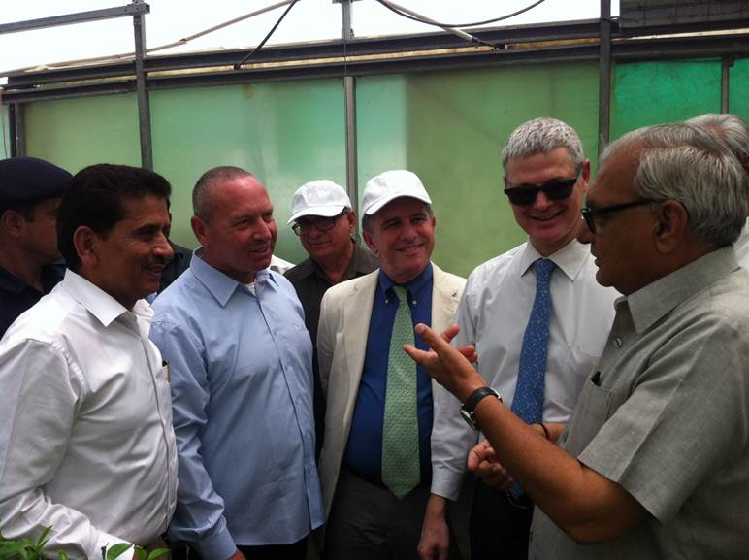

*From right to left: Haryana CM Bhupinder Singh Hooda, Ambassador of Israel Alon Ushpiz, Head of MASHAV Daniel Carmon, Israeli Embassy Agriculture Counselor Uri Rubinstein and  DG Horticulture Dr. Satyavir Singh*

*New Delhi, 21st May 2013:*The Chief Minister of Haryana, Mr. Bhupinder Singh Hooda, and Ambassador of Israel, H.E. Mr. Alon Ushpiz, inaugurated today a Centre of Excellence for Fruits in Mangiana, Sirsa. Together with them was Ambassador Daniel Carmon, Deputy Director General of Israel's Ministry of Foreign Affairs and Head of MASHAV, Israel's agency for International Cooperation and Development.

The event was attended by Agriculture Minister of Haryana, Mr. S Paramvir Singh, MP (LS) Mr. Ashok Tanwar, and other senior officials of the Haryana Government.

This is the second Indo-Israel Centre of Excellence to be established in the State of Haryana, following the Centre for vegetables in Karnal. It will serve as yet another focal point for Indo-Israeli agriculture R&D, and will showcase some of the most advanced Israeli nursery and fruit cultivating technologies, adapted for Indian conditions by local experts.

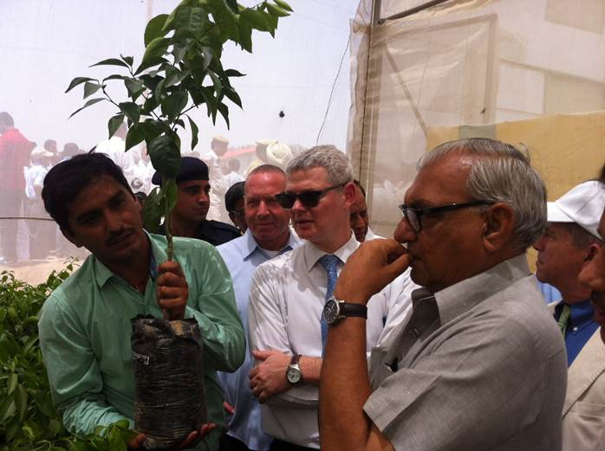

*Chief Minister Bhupinder Singh Hooda along with Ambassador Alon Ushpiz inspects*

*a sapling at the Indo-Israel Centre of Excellence for Fruits in Sirsa, Haryana*

Under the three year workplan for Indo-Israel cooperation in agriculture, 30 Centres of Excellence in 10 states across India are in various stages of development. Proper implementation and adaptation of Israeli technologies has been shown to drastically multiply production and to significantly raise produce quality.

While addressing the audience, Ambassador Ushpiz praised Chief Minister Hooda for his vision, leadership and commitment for the betterment of Haryana’s farmers and Haryana’s people. "You have put the most efficient and dedicated people on the ground and the results are self-evident", Ushpiz told Chief Minister Hooda. "This dedication, commitment and professionalism, has put Haryana in a clear leadership position in the field of advanced agriculture", Ambassador Ushpiz added. He thanked Union Minister of Agriculture, Mr. Sharad Pawar, for his long term vision and for his long-standing support, determination and belief in the agriculture cooperation between Israel and India.

The Cheif Minister said that the Indo-Israel Centre of Excellence for Fruits will be a milestone in the development of the State's horticulture sector, and will give Haryana's farmers a competitive edge in the national and International market.

During his three day visit to India, Ambassador Daniel Carmon, who heads Israel's International Cooperation and Development Agency, MASHAV, also visited the existing Indo-Israel Center of Excellence in Karnal. He is scheduled to meet Union Minister of Agriculture, Mr. Sharad Pawar, and other senior officials in the Ministry of Agriculture and the Ministry of External Affairs.