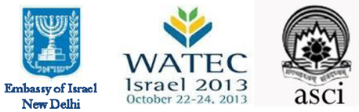

**PRESS RELEASE**

**Learning Water Smart Solutions from Israel**

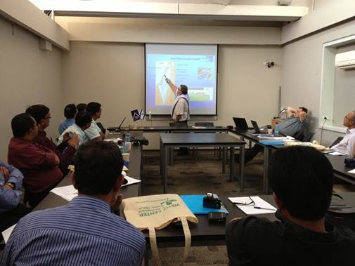

*New Delhi, 17th October 2013:*

A delegation of 30 Indian water experts and professionals is expected to visit Israel next week to learn more on water technologies and solutions and will focus on finding suitable urban water solutions for India's water challenges.

The delegation is comprised of decision makers, engineers and local and municipal commissioners, including the Mayor of Chandigarh, the Chief Engineer of Delhi Jal Board and many other officials from different municipal institutions as well as research organizations. The distinguished group will also participate in WATEC 2013, one of the most innovative water & environmental technologies exhibitions in the world, which is scheduled to take place in Tel Aviv on 22-24th of October 2013.

The Embassy of Israel in coordination with the Administrative Staff College of India (ASCI) has organized the delegation.

Having coped with water scarcity for more than 60 years, the State of Israel has gained experience in developing unique solutions for fields such as intelligent water resource management, irrigation technologies, water quality, water purification, wastewater restoration, desalination and water security. Israel, with its innovative and vibrant industry, has become a major world player in these areas, supplying some of the most useful practical solutions to this critical challenge.

Israel is a world leader in the proportion of water it recycles by treating 80% of the country’s sewage and 100% of the sewage from the Tel Aviv metropolitan. Spain, at the second place, treats 12% of its water. The treated water is later reused as irrigation water for agriculture and public works.

Attracting participants from more than 100 countries, WATEC 2013 will expose the latest Israeli technological innovations in a wide spectrum of fields, and introduce them to business executives, decision-makers, leading researchers and other professionals. The exhibition will offer the most comprehensive forum where water industry executives, academia, institutional investors, venture capitalists, analysts, and other experts have the opportunity to shape future collaborations with a wide range of possible partners; from start-up businesses through established companies.

The event will focus on one of the most significant challenges globally today of optimizing the usage of natural water resources, due to the rapid growth of population. It is clear today that technologies can serve as a key to a much more efficient exploitation of natural resources (water, soil, energy and materials).

The training during the conference for the Indian water experts from the municipal institutions such as Delhi, Mumbai, Hyderabad and Chandigarh, will feature compelling solutions as well as proven practical applications in areas such as water and energy efficiency, water quality, desalination, customer relations, and water supply.

Talking about the delegation, Head of Economic and Trade Mission of Israel to India, Mr. Yonatan Ben Zaken, said: “We are proud to host this respectable delegation, coming to Israel in order to learn from our rich experience in water management and past mistakes. Israel is a master in enhancing efficiency and conservation of water. Our motto is "do more with less" – in all aspects; energy, loss of water and cost”.

*For further information, please contact: Mr. Vineet George, Press & Information Officer, Embassy of Israel, Tel: +91-9990997437 (M), email:*[spokesman-asst@newdelhi.mfa.gov.il](mailto:spokesman-asst@newdelhi.mfa.gov.il).