

**Embassy of Israel**

**New Delhi**

**PRESS RELEASE**

**Israeli Economic Minister visit to India**

**(7-10 October 2013)**

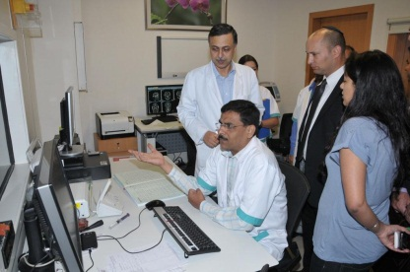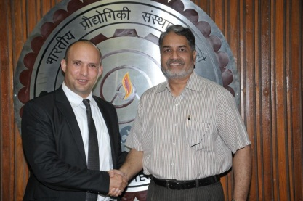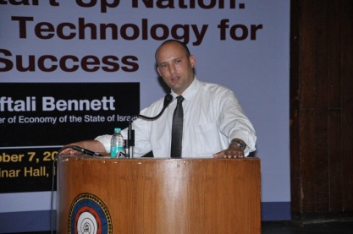

*New Delhi, 9th October 2013:* The Honourable Minister of Economy of Israel, H.E. Mr. Naftali Bennett is presently on a working visit to India with a large delegation of Economy Ministry Officials  and Israeli businessmen. The delegation is scheduled to visit Delhi and Mumbai.

The visit is expected to enhance the good cooperation between the two sides in the field of economy, commerce, trade, innovation and R&D.

During his visit to Delhi, Minister Bennett addressed a gathering at the CII event. He said, “The bilateral trade (between India and Israel) could easily be doubled in the next five years, if we take this FTA forward." India and Israel, which commenced the negotiations in 2010, had concluded the seventh round of talks in June this year. The next round of negotiations for the pact will be held here in November.

Minister Bennett also addressed students of IIT Delhi where he stressed on the values Indians and Israelis share. “Israelis are very much like Indians, they respect education and family values and are good with jugaad,” he said during a seminar.

Bennett along with an Israeli delegation also inspected CoE for vegetables at Karnal, Haryana. Showing satisfaction with the center, Bennet said: “We are determined to increase India's milk production by five folds. Our government will make all efforts to help the Indians to increase productions of fruits, vegetables and milk.”

During his visit, Bennett also met Finance Minister Chidambaram, Commerce and Industry Minister Anand Sharma and Communications Minister Kapil Sibal.

"Together with discussion with the Minister (P. Chidambaram) we are going forward with a joint R&D fund, which essentially will be a joint Indo-Israeli fund for R&D where an Israeli company will partner with Indian company and then apply for funds. It will get 50 percent of the cost of R&D project," he said at a Media Briefing in Delhi. Bennett said he also discussed FTA related issues with Sharma. "I have discussed this extensively with the minister of commerce. Together we decided to progress. We will be meeting in Jerusalem in about a month from now. And the minister and I then decided again to meet in Bali in December. Both sides are very keen."

Bennett also invited HCL Technologies to invest in Israel for greater collaboration in the information technology space.

Bennett is leaving for Mumbai today where he is expected to meet the chairman of Tata Group, Cyrus Mistry and chairman and managing director of Reliance Industries Ltd. Mukesh Ambani.

(Note: You are free to use the text and pictures for publication)