

**Embassy of Israel**

**New Delhi**

PRESS RELEASE

**Ambassador of Israel Hosts the Annual Iftar Dinner in New Delhi**

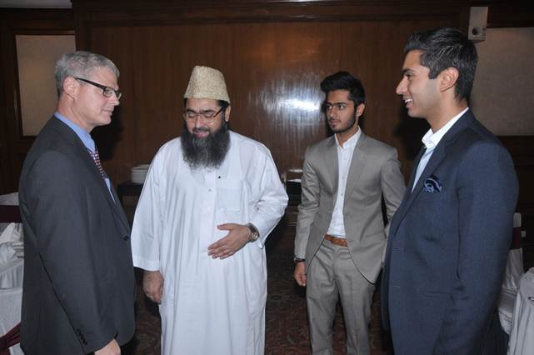

*New Delhi, 2 August 2013*: The Ambassador of Israel, Mr. Alon Ushpiz, hosted the annual Iftar dinner yesterday for over 60 prominent members of the Muslim community in India. Civil society figures, politicians, religious leaders, artists, scholars, business leaders and journalists attended the Iftar dinner.

After the crowd broke the fast with dates from Israel, Ambassador Ushpiz spoke of the ancient relationship and brotherhood between the Jewish and Muslim communities. Ambassador Ushpiz quoted the words of the Israeli President, Shimon Peres, stating that "Ramzan is not only a holiday for you, but a celebration to all of us. After all, we are coming from the same family - the family of Abraham (Hazrat Ibrahim)". He added that "It is important to remember that by hosting Iftar celebration, we are not just reaching out to the Muslims of India, but also representing the Muslim community in Israel itself who constitute 18% of the population".

The Ambassador concluded his words wishing that this Ramzan brings peace and prosperity in West Asia, noting that that the peace talks between senior Israeli and Palestinians leaders had finally resumed after three years of deadlock and that the two delegations had celebrated Iftar together in Washington.