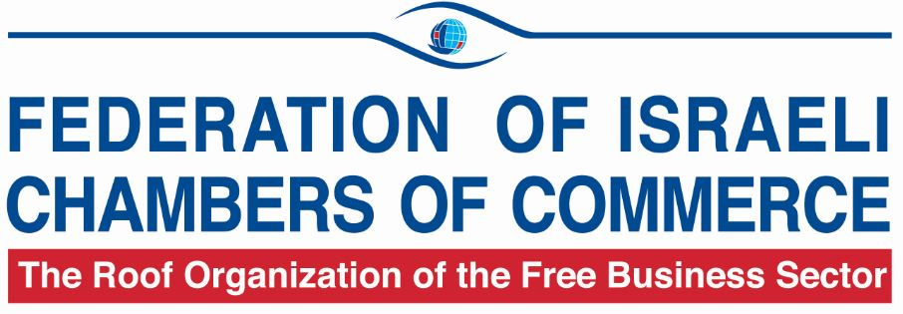

84 Hahashmonaim St. Tel-Aviv 67132, Israel
Tel: 972-3-563 1020, Fax: 972-3-561 9027
E-mail: chamber@chamber.org.il http//www.chamber.org.il

BUSINESS OPPORTUNITIES FROM ISRAEL

Company Name | KNS Global Opportunities Ltd.
Contact Person | Mr. Jacky Shloush, CEO
Address | 12c Rozen Pinhas St., Tel-Aviv 6951235, Israel
Telephone No. | 972-73-7862294/ Mobile: 055-5942294
Fax No. | 972-73-7872294
E-Mail | jacky.shloush@kns-go.com
Website | www.kns-go.com
Year of Establishment | 2006
No. of Employees | 7
Summary of offer | Export of Fried Onions in Cans and in Aseptic Bags of 3Kg, 10Kg, 20Kg and up to 1000Kg.
Description of offer | KNS Global Opportunities Ltd. company is in the field of food industry where we produce and sale fried onion for retail chain supermarket in cans of 190 Gram and 400 Gram and fried onion in aseptic bag of 3Kg, 10Kg, 20Kg and up to 1000Kg for the big factory of food, salad meat, soap and bakery. with Hallal and as well with high kosher supervision certification.  The onions are peeled, diced fried and packed in unique packages which preserve their freshness entirely without human intervention.  The fried onion is of high quality and natural.  Our fried onion is very unique and make the life more easy to use.  The product has a long shelf life of 24 months UN cooled and after opening - up to 7-10 days in cooling.  As we are capable of producing up to 150-170 tons of fried onions a day, we can promise you regular delivery at a competitive price all year long, unaffected by onion’s market price. and most importantly, the dicing, mess, frying, hard work and waste (over 70%) stay with us. We have the all certification of ISO 9001, ISO 22000, HACCP, BRC.  Looking for distributors, factories of food products, bakery food industry, salad factories, tomato sauce factories. Etc.  We are ready to send samples to check our product with all documentation.
Target Countries | All Countries.

Company Name | Ultram Technologies Ltd.
Contact Person | Mr. Yossi Yuran, General Manager
Address | 58 Hameyasdim St., Mazor 73160, Israel
Telephone No. | 972-3-9331696/ Mobile: 972-50-8533401
E-Mail | yossi@ultramtech.co.il
Website | www.ultramtech.co.il
Year of Establishment | 26
No. of Employees | 6
Summary of offer | Representation, Import and Marketing of Electronic Components
Description of offer | We are seeking to promote and represent foreign manufactures in the Israeli market, as well as customers for Israeli made RF and Microwave products.  Products:  RF and microwave components and systems, Coaxial Cables, Satellite communications, Electro-optics.
Potential Partners | RF and microwave components and systems, Coaxial Cables, Satellite communications, Electro-optics Manufacturers.
Target Countries | USA, Europe, China, Korea.

Company Name | Trade Dory
Contact Person | Mr. Dotan Gilad
Address | 12 Abba Hilell St., Ramat-Gan, Israel
Telephone No. | 972-50-4460500
E-Mail: | info@tradedory.com
Website | www.tradedory.com
Year of Establishment | 2010
No. of Employees | 10
Summary of offer: | Cooperation / Business Opportunities / Import - Export  for Israel - Brazil - Latin America
Description of offer | Trade Dory - helps creating business opportunities among Israeli & Brazilian / Latin America companies as focused and worldwide companies.  We help Israeli companies who want to enter a new market around the world, and we help Brazilian / Latin America companies who are interested in local assistance in Israel.  We believe in providing the best solution for customers through understanding the needs and unique characteristics of each country.  We offer a wide range of unique solutions & technologies :  Water Treatment Technologies / LED Street Lighting 80% Energy Saving / Smart Cities Solutions / Agriculture & Food Innovation Technologies / H.L.S / Defense & Access Control Systems.
Target Countries: | Latin America.

Company Name | EL - REY SALVADOR Ltd.
Contact Person | Mr. Dario Vainnman, Project Manager
Address | Tirat Hacarmel
Telephone No. | 972-4-6442221, Mobile: 972-050-8911777
Fax No. | 972-4-6442223
E-Mail | dario@erslighting.com
Website | www.erslighting.com
E-Mail | dario@erslighting.com
Year of Establishment | 1995
No. of Employees | 10
Summary of offer | Export of Advanced Light Systems
Description of Offer | El Rey Salvador Ltd. team specializes in developing and manufacturing advanced light systems since 1995, implementing LED technology for the lighting market for customers from different fields: architecture, military, industry, agriculture and many others.
Potential Partners | Electricity Contractors, Architects, General industry, Agriculture.
Target Countries | All countries.
Other Information | • The company provides services for various manufacturers, such as: LED UV manufacturers for water purification, photo industry, night vision and other systems which require special lighting conditions in order to perform properly.  • El Rey Salvador LTD provides lighting fixtures for growing vegetables, flowers, poultry and more, after years of cooperation with various researches which explored the optimal grow habitat lighting conditions for inducing agriculture growth.

Company Name | Neway Traffic Safety Equipment Ltd.
Contact Person | Mr. Dekel Halivni
Address | 6, Hayetzira St. Industrial Zone, Rosh Ha'ayin 4801738, Israel
Telephone No. | 972-3-9031866 (Ext 112) / Mobile: 972-53-8222357
Fax No. | 1533-9011684
E-Mail | Dekel@neway1.co.il
Website | www.neway1.co.il  www.neway-or.co.il
Year of Establishment | 2003
No. of Employees | 90
Summary of offer | Import, Export, Services and Joint Ventures:  Road Safety, Concrete Elements, Renewable Energy Lighting
Description of offer | All the road products and solution available under one roof!  New Way Traffic specializes in developing, manufacturing, marketing, and installing road safety accessories, and in painting roads and parking lots.  Our extensive experience, professional team and availability make us the perfect solution for you!  Our emphasis is on safety and reliability.  We provide a wide variety of traffic services and products.  All our services and products meet the strictest standards, and have been approved in accordance with the Netivei Israel standard, the inter-ministerial committee, EU standards and the Standards Institution of Israel.  • New Way brings the green energy revolution to Israel.  • The company specializes in manufacturing, supplying, installing, and developing green product in various technologies: LED/induction and solar.  • We integrate advanced technologies in the field of safety accessories and road infrastructures.  • We make use of induction and LED lighting and road and street lighting that give 50% savings in power consumption.  • Among our clients are Netivei Israel, the Israel Electric Company, Mekorot, KKL, the Ministry of Defense, numerous municipalities and many local authorities.  New Way Traffic Ltd. continually strives to find innovative solutions and to improve road safety.  Our approach is to provide both excellence and an immediate response to every client.
Potential Partners | Companies engaged in similar fields or launch fields, businessmen, Israelis and locals looking for a company to advise and manage projects in our fields.
Target Countries | Latin America, Africa and Asia.
Other Information: | Open to any idea, suggestion, cooperation or representation in case of business and economic potential, even if not in our fields.

Company Name | Subli-Art by Zikit Digital Ltd.
Contact Person | Mr. Noam Azogui
Address | 6 Ravnizky St., Sgula Industrial Park, Petach Tikva 4900617, Israel
Telephone No. | 972-3-9131413 / Mobile: 972-54-7852224
Fax No. | 972-3-9044011
E-Mail | info@subli-art.com
Website | www.subli-art.com
Year of Establishment | 2000
No. of Employees | +20
Summary of offer | Looking for cooperation - sublimation supplies, photo crystals, badges, textiles, advertising materials and related printing services widely welcomed as corporate gifts, souvenirs, premiums, personal gifts
Description of offer | Zikit Digital Ltd., founded in 2000, specializes in short and medium run manufacturing, limited edition requests and marketing sublimation supplies, photo crystals, badges, textiles, advertising materials and related printing services widely
Potential Partners | Resellers of sublimation machinery and supplies.
Target Countries | All countries
Other Information | Subli-art is a new concept trademark introducing innovations and inventions of new products and applications every other day.

