The Robert H. Smith Faculty of Agriculture, Food & Environment
The International School of Agricultural Sciences


STATE OF ISRAEL
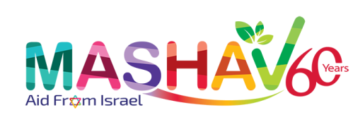
Israel's Agency for International
Development Cooperation
Ministry of Foreign Affairs


MASHAV - Israel’s Agency for International Development Cooperation
&
The Hebrew University of Jerusalem
The Robert H. Smith Faculty of Agriculture, Food & Environment
The International School of Agricultural Sciences
invite professionals
to participate at our upcoming Mashav Program:
FEEDING THE FUTURE: FOOD SAFETY AND TECHNOLOGY IN TIMES OF GLOBAL CHANGE

June 19 – July 7, 2022

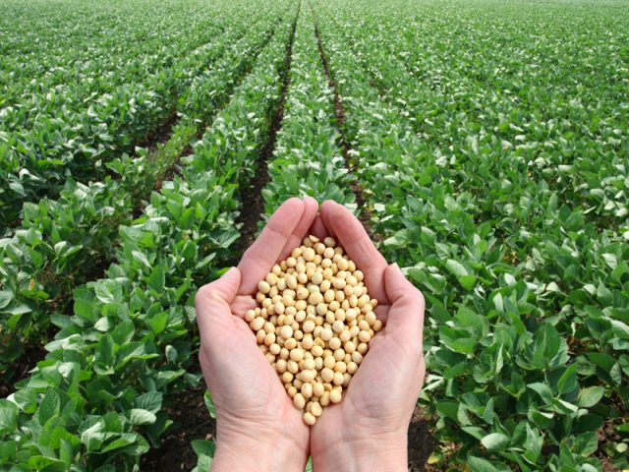

About the Course

Background
In cooperation with the Hebrew University of Jerusalem's Faculty of Agriculture – MASHAV's only academic affiliate – we are pleased to announce the opening of a training and capacity building program on
Feeding the Future: Food Safety and Technology in Times of Global Change.
The course will be held at the Robert H. Smith Faculty of Agriculture, Food and Environment, The International School of Agricultural Sciences, in Rehovot, Israel, from June 19 – July 7, 2022.

Aims
In numerous countries around the world, a significant portion of the population suffers from malnourishment. Raising more indigenous crops with higher levels of nutritious protein is one strategy to address food security. However, even a sufficient supply of a nutritious crop may not sustain the population if the safety of the food is compromised.
Improperly treated crops and unsanitary handling, as well as intentional and accidental poisoning, can threaten the food supply. There is a need for appropriate measures to ensure safe and sanitary conditions in all steps of the chain of supply and trade; from cultivating and harvesting the crop to processing, packaging, shipping, and storing food.

Objectives
The program's objectives are:
• To provide participants with management skills for confronting hazards and threats in the food industry.
• To gain awareness of potential health hazards during the cultivation, processing, packaging, handling, transportation, and storage of food.
• To discuss emerging trends for improving the safety of food sources from the participants’ countries.
• To adopt protective actions to minimize contamination of food in the participants' region.

Main Subjects
This program's topics of study will include:
• Risk Management in Food Cultivation and Production
- Hazards in Water Handling in the Food Industry.
- Food Packaging Hazards.
- Beneficial Aspects of Functional Foods.
• Hazard Analysis of Critical Control Points: Implementation in the Food Industry
• Environmental Management in the Food Industry.

Study Conditions
Classes will be held at the Faculty’s Rehovot campus; around-the-clock computer access will be provided. We recommend that participants who own a personal computer bring it with them for their own convenience.
Scientific material will be assigned.
Professional trips will be held (if COVID-19 regulations allow).
Full attendance is required.
*We reserve the right to make changes in the academic program.

Application

Application Requirements
Candidates interested in attending this program require:
• Α M.Sc. degree or higher in biology, biotechnology, environmental sciences, food technology, or agriculture from a recognized university. A detailed record of studies and copies of degrees must be included with application forms.
• Documentation of academic studies conducted in English OR a TOEFL score of at least 89 on the internet-based scale OR an internationally recognized equivalent. The language of instruction is English, therefore, participants whose native tongue is not English, must furnish proof of proficiency in this language.
• Professional experience in the field is recommended.
• Basic knowledge in microbiology, chemistry and human physiology and/or nutrition.
• An official certificate of good health signed and stamped by a doctor.
• Two letters of recommendation from the candidate's place of work or university.

Application Forms
Application forms can be found at the end of this document.

Completed applications MUST be sent directly to the nearest Israeli diplomatic or consular representative by April 14, 2022. The forms must be sent as one PDF document.
Course Completion
Each participant will prepare a seminar presentation, which will be reviewed and graded. It should apply knowledge acquired during the course to a topic in food safety. Participants are advised to bring with them digitalized data relevant to their countries, especially on food legislation. On completion of the course and fulfillment of its requirements, participants will receive certificates.
General Information

Arrival and Departure
Arrival and opening date: 19/6/2022
Closing date: 7/7/2022
Departure date: 7/7/2022, preferably late at night.
Participants must arrive at the training center on the arrival date, and leave on the departure date. Early arrivals/late departures if required, must be arranged by the participants themselves, directly with the hotel/center, and must be paid for by the participant him/herself.
Weather
The weather in Israel during the months of June and July is hot and humid, approximately 24-35°C. Participants are requested to bring light clothes suitable for hot weather, including bathing suits, hats and comfortable closed walking shoes. All buildings and forms of transportation are air-conditioned and may be chilly. There is no need to bring a raincoat or an umbrella since it never rains in this season. Along with avoiding excessive exposure to the sun, visitors should wear hats and use sunscreen.

MASHAV Scholarships
MASHAV awards a limited number of scholarships. The scholarship covers the cost of the training program including lectures and field visits, full board accommodation, medical insurance (see below) and transfers to and from the airport. Airfares and daily allowance are not included in the scholarship.

Medical Insurance
Medical insurance covers medical services and hospitalization in case of emergency. It does not cover the treatment of chronic or serious diseases, specific medications taken by the participant on a regular basis, dental care and eyeglasses. Health authorities recommend that visitors to Israel make sure they have been inoculated against tetanus in the last ten years. Subject to the full binding policy conditions. Participants are responsible for all other expenses.

Covid-19 regulations - In accordance with the guidelines of the Ministry of Health:

1. All trainees are required to do a PCR test up to 72 hours before their flight to Israel. Upon arrival in Ben-Gurion Airport, trainees (all travelers) will be required to do a second PCR test, and then to go into isolation until receipt of a negative result. The test in Israel is coordinated and fully funded by MASHAV.

2. In case they receive a positive result for the PCR test upon entering the country, they will be required to remain in isolation according to the guidelines of the Ministry of Health on the day of entry. Currently, the stay in isolation is the responsibility of the Ministry of Health.

3. Trainees vaccinated with Sputnik (and only they) are required to undergo a serological test in addition to the PCR test if they want to avoid full isolation ( up to 7 days) in case of exposure to a person with Covid. It is up to the responsibility of the participants to update us in case of need. In case needed, MASHAV can arrange the test in Israel.

4. All trainees must fill out the Ministry of Health form at the following link up to 48 hours before the flight: https://corona.health.gov.il/en/flights/
After successful completion of the form, trainees will receive confirmation from the Ministry of Health. You can present a digital copy of this confirmation, or you can print it.

5. Only those who receive confirmation from the Ministry of Health and the negative PCR test result will be able to enter the country.

6. To be on the safe side, trainees should make sure that any financial commitments related to their travel has the option of cancellation /change/full refund.

7. Health Insurance – all those who enter Israel should acquire a health insurance that COVERS Covid-19. MASHAV insurance covers standard medical treatment of Covid-19 only for those who contract the Covid-19 during their stay in Israel. It does not cover any additional, related costs.

Location and Accommodations
The course will take place at The Hebrew University’s Robert H. Smith Faculty of Agriculture, Food & Environment, situated in Rehovot. Participants will be accommodated in single bedrooms in shared apartments in our fully equipped guesthouse on campus.
About MASHAV
MASHAV – Israel’s Agency for International Development Cooperation is dedicated to providing developing countries with the best of Israel’s experience in development and planning. As a member of the family of nations, The State of Israel is committed to fulfilling its responsibility to contribute to the fight against poverty and to the global efforts to achieve sustainable development. MASHAV, representing Israel and its people, focuses its efforts on capacity building, sharing relevant expertise accumulated during Israel's own development experience to empower governments, communities and individuals to improve their own lives.
MASHAV’s approach is to ensure social, economic and environmental sustainable development, and is taking active part in the international community’s process of shaping the Post-2015 Agenda to define the new set of the global Sustainable Development Goals (SDGs).
MASHAV’s activities focus primarily on areas in which Israel has a competitive advantage, including agriculture and rural development; water resources management; entrepreneurship and innovation; community development; medicine and public health, empowerment of women and education. Professional programs are based on a “train the trainers” approach to institutional and human capacity building, and are conducted both in Israel and abroad. Project development is supported by the seconding of short and long-term experts, as well as on-site interventions. Since its establishment, MASHAV has promoted the centrality of human resource enrichment and institutional capacity building in the development process – an approach which has attained global consensus.

About The Hebrew University of Jerusalem
The Hebrew University of Jerusalem was established in 1925, preceding the establishment of the State of Israel by more than two decades. The University was designed to be a world-class institution of higher learning and research. Today, the Hebrew University comprises seven faculties, over 100 research centers, a student body of about 23,000 and a tenured-track faculty of some 1,500. One third of its enrollment is at the M.Sc. and Ph.D. level.

The Robert H. Smith Faculty of Agriculture, Food & Environment
The Hebrew University’s Robert H. Smith Faculty of Agriculture, Food & Environment was established in 1942 in Rehovot, a city about 55 km from the main campus of the University in Jerusalem. The site was chosen because of its climate and soil conditions. It is the only agricultural institution of higher education in Israel offering university degrees. The International School of Agricultural Sciences aim is to expose academic graduates from abroad to post-graduate programs, giving them insight into the achievements and research of Israel in general and of the Faculty in particular, expanding their knowledge in specific fields and creating opportunities for international cooperation.

