 | June 14-18
Dear friends,  During these challenging days, MASHAV decided to conduct a series of online lectures addressing current issues. | 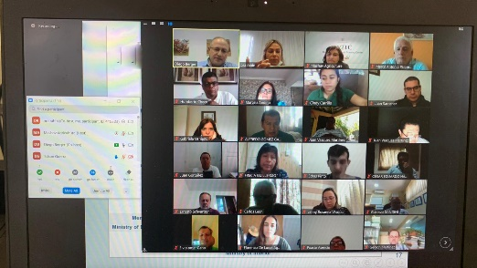
Join us at our next online events:

WHEN: Monday, June 15th  15:00 hours (Israel time)  “Women’s Political Involvement in Crisis Intervention” (English)  Lecturer – Dr. Orit Rishpi  Co-founder of WEPOWER – for the Enhancement of Women to Politics and Decision Making Positions  Zoom link: https://us02web.zoom.us/meeting/register/tZ0vcOyopzksH9bMie2ojFk1OmK50KVxueE8  Facebook link:  https://www.facebook.com/goldameirmountcarmel/photos/a.242767262418732/3821049864590436/?type=3&theater | 
WHEN: Tuesday, June 16th  16:30 hours (Israel time)  “Resiliencia comunitaria y recursos de servicios comunitarios en tiempos de crisis” (Spanish)  Lecturer – Horacio Kurland  Expert and Consultant in Organizational Communication and Community Development  Zoom link: https://us02web.zoom.us/meeting/register/tZEkdeipqDgqGtHFKdtg-0--7VbU3BMZWnUV  Facebook: https://www.facebook.com/goldameirmountcarmel/photos/a.242767262418732/3830380893657333/?type=3&theater | 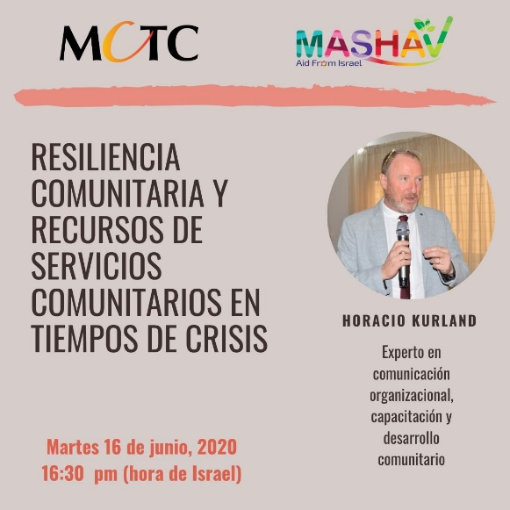
When: Tuesday, June 16th  15:00 hours (Israel time)  “From vision to reality and from innovations to advanced water technologies – The methodology and activities that led Israel to independence in water supply in the arid Middle East” (English)  Lecturer: Prof. (Em.) Eilon M. Adar Ph.D  Prof. Emeritus in Arid Zones Hydrogeology and Soil Water Engineering  Register in advance for this meeting:  Zoom register in advance for this meeting: https://did.li/Hl6ql  Meeting ID: 819 1079 7285 | 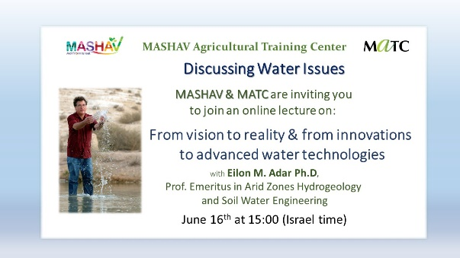
WHEN: Monday, June 15th  14:00 hours (Israel time)  “From Global Disruption to Educational disruptive innovation –School Principals” (English)  Lecturer: Lilac Wasserman  Organizational Development & Educational Intrapreneurship  Event on Facebook: https://www.facebook.com/events/547289539482281/  Post on Facebook: https://www.facebook.com/OfriCenter/photos/a.10150440615743666/10157555079783666/?type=3&theater  Link to Registration: https://bit.ly/3cG7iSP | 

