 | SEPTEMBER 13-17
Dear friends,  During these challenging days, MASHAV decided to conduct a series of online lectures addressing current issues. | 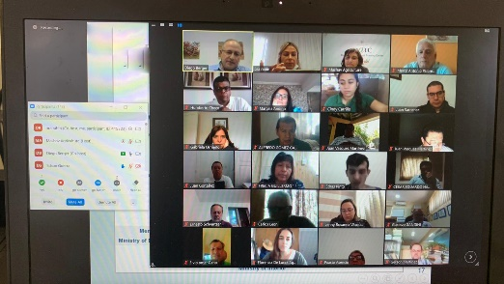
Join us at our next online events:
WHEN: Monday, September 14th 12:00 hours (Israel time)  “The Impact of COVID 19 in Sustainable Development and the SDGs ” – (English)  Lecturer – Dr. Amber Hill, Expert in Sustainable Agriculture at Tel Hai College  Zoom register in advance for this meeting: https://us02web.zoom.us/meeting/register/tZYrdu6hrjsvGdPT4fmqbRlUC30ErZzX_X_w |  | 