MASHAV - Israel’s Agency for International Development Cooperation together with

MATC – MASHAV Agricultural Training Center are inviting professionals to participate in an

International Webinar on :

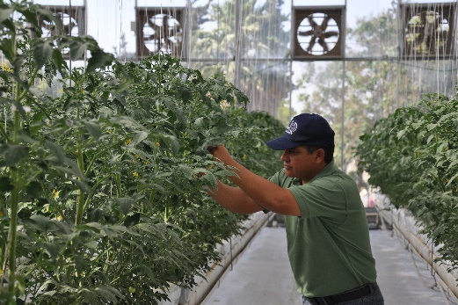**“Food security - Introduction to** **Greenhouse Technologies”**

**5 Online Meetings**

**02.7 – 30.7.2020**

***Background***

With the transformation of the lifestyle of many communities around the world and increased awareness of nutritional security, there is a need for fresh, high quality and locally produced vegetables. Since most vegetables are seasonally grown, only the use of greenhouses or other types of structures such as net houses or tunnels will enable veg production and supply throughout the year. The planning of greenhouses requires an analysis of climate and environmental data, correct choice of structures and covers, implementation of irrigation, climate control technologies and others.

***Aims***

The webinar aims to share with participants, Israel's experience in developing intensive and sustainable vegetable production systems focusing on the characterization and design of greenhouses.

***The program***

The webinar will be conducted by Mr. Roy Peleg and will take place during 5 online meetings including a virtual field visit to a greenhouse. The meetings will take place at 13:00 (Israel time) and have a duration of around 90 minutes.

02/7 - Greenhouse structures and covers

09/7 - Climate Means

16/7 - Growing & monitoring systems

23/7 - Virtual Field Visit

30/7 – Final discussion & Conclusions

***Requirements***

The webinar is geared towards professionals from the public or private institutions and organizations, involved in the development of the vegetable sector. A full command of English is required. Attendance will be compulsory. Participants who meet this requirement will receive a certificate.

***Application***

Those interested are invited to complete the attached form and submit it through the nearest Israeli mission

until June 17th, 2020. Given the limited number of spaces, there will be a selection process. Selected applicants will receive confirmation through the Israeli Embassy in their country until

For further information, please contact: